Name: Class: Mark:

1. A deluxe dog kennel is being designed which will have the following features:
- A heat pad which turns on if the temperature is below 18ºC
- A water bowl which refills if below a certain level
- A window fan which blows air into the kennel if the humidity is greater than 70%
- A digital camera which takes a photo if the dog barks
- A ‘Doggy home’ light which turns on if the dog is in the kennel
For each of the features, complete the table below to state a suitable sensor
that could be used. [5]
Feature | Appropriate sensor
A
B
C
D
E
2. Screens are manufactured using different types of technology.
(a) Most televisions and computer screens now use LCD technology. These are back-lit using LEDs or a fluorescent (CCFL) bulb.
(i) State what each of the initials below stands for: [2]
LCD:
LED:

(ii) Give three advantages of using LED technology rather than a fluorescent
bulb for back lighting. [2]

(b) Projectors are used in school classrooms, business presentations and cinemas.
State two technologies that are used for digital projectors. [2]

3. A library uses a barcode scanner to scan the barcode in a book when a library user borrows or returns the book.
(a) Describe why a barcode scanner is required. [4]

(b) Describe one other application that makes use of barcode scanners. [2]

4. A restaurant decides to use QR codes so that customers are able to browse the menu on their phones.
(a) Define a QR code. [1]

(b) Describe how a potential customer could use the QR codes to browse the menu. [2]

5. A smartphone manufacturer decides to use a capacitive touch screen rather than a resistive touch screen on a new phone.
(a) State one other technology which is used on touch screens. [1]

(b) Explain two benefits of using a capacitive touch screen rather than a resistive one. [4]

6. A steel manufacturing company uses a gas furnace to heat the steel to its required temperature.
The temperature of the furnace can be increased or decreased by controlling a gas supply valve. The whole process is controlled by a computer system which receives data from sensors in the furnace.
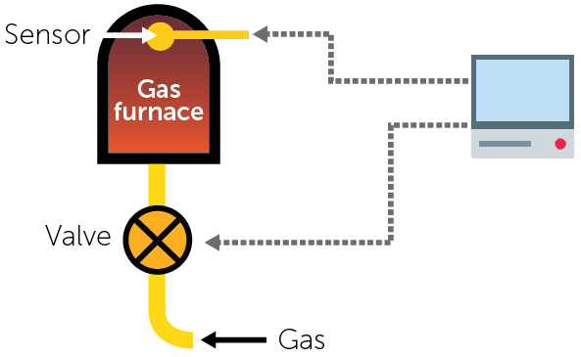
(a) Name a suitable type of sensor for this application. [1]

(b) Describe how the sensors and computer interact to control the temperature
of the furnace. [4]

7. Complete the following table by naming a suitable sensor for the given application. [5]
Sensor | Application
 | Detection of an intruder in a burglar alarm system.
 | Monitor the acidity levels in a chemical manufacturing plant.
 | Automatically turn on the lights in a school corridor if someone is walking down it.
 | Determine if a smartphone is orientated in landscape or portrait.
 | Monitoring air pollution levels at the side of a main road.
8. A school has just held a musical and decided to give everyone who took part a photo of the cast and crew.
They decide to use an inkjet printer to make the photos.
(a) State one other type of printer that they could have used. [1]

(b) Describe how the inkjet printer works to print the photos. [3]

9. A manufacturer of handheld puzzles first makes their designs using clay.
(a) Describe how a 3D scanner would be used to create a 3D model of the clay
designs on a computer. [3]

(b) The company will make changes to the 3D model before printing the designs using a 3D printer.
Describe how a 3D printer is able to print the model. [3]

(c) Once the model is complete it will be photographed so that the designers have a reference of the design. The photograph will be saved on a computer.
State an input device that would be used to take the photograph. [1]

(d) Other than prototype designs, give two other uses for 3D printers. [2]

(e) The designers of the puzzles will make changes to the 3D model before it is sent
to the 3D printer.
Explain one input device they will use to make these changes. [2]

[Total 50 marks]

